**Welcome Back Turtle Assignment:**

1. 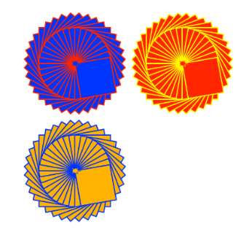Create a Python Turtle program to do the following:
2. Draw an interesting shape using multiple basic shapes   
   and pen colors.
3. Use the **goto(x,y)** function to move the starting point for the shape   
   to a different location on the output window.
4. Use a **counted loop** to draw multiple copies of your shape at different   
   positions on the output window.
5. Use the **input()** function to ask for a number of times to repeat the shape. Use this number to control the repeat of the counted loop.
6. Extension. Check the repeat number input to make sure it is a valid number and that it is between the range of 1 to 6 repeats.
7. Use print screen to copy and paste an image of your program output below.

Images are on next page

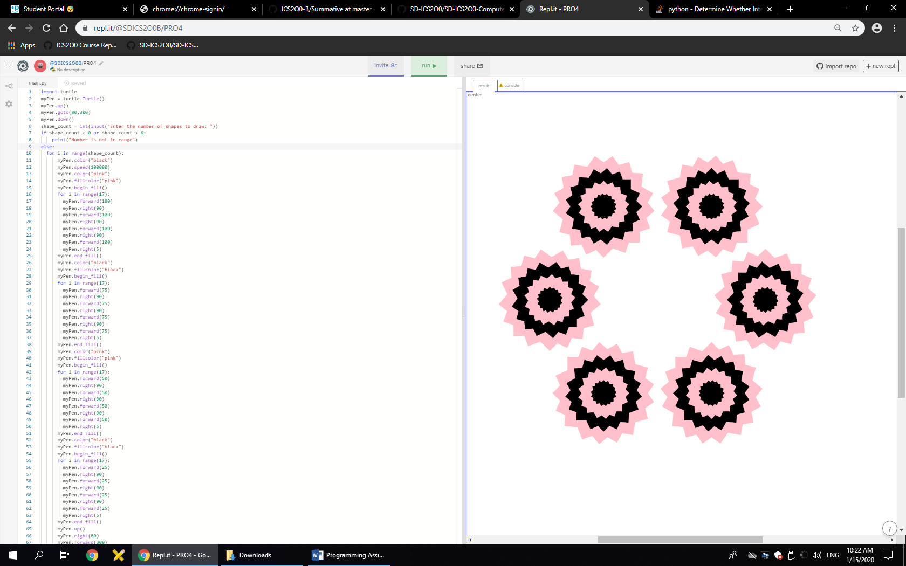



1. Provide a listing of your Python program below.

import turtle

myPen = turtle.Turtle()

myPen.up()

myPen.goto(80,300)

myPen.down()

shape_count = int(input("Enter the number of shapes to draw: "))

if shape_count < 0 or shape_count > 6:

print("Number is not in range")

else:

for i in range(shape_count):

myPen.color("black")

myPen.speed(100000)

myPen.color("pink")

myPen.fillcolor("pink")

myPen.begin_fill()

for i in range(17):

myPen.forward(100)

myPen.right(90)

myPen.forward(100)

myPen.right(90)

myPen.forward(100)

myPen.right(90)

myPen.forward(100)

myPen.right(5)

myPen.end_fill()

myPen.color("black")

myPen.fillcolor("black")

myPen.begin_fill()

for i in range(17):

myPen.forward(75)

myPen.right(90)

myPen.forward(75)

myPen.right(90)

myPen.forward(75)

myPen.right(90)

myPen.forward(75)

myPen.right(5)

myPen.end_fill()

myPen.color("pink")

myPen.fillcolor("pink")

myPen.begin_fill()

for i in range(17):

myPen.forward(50)

myPen.right(90)

myPen.forward(50)

myPen.right(90)

myPen.forward(50)

myPen.right(90)

myPen.forward(50)

myPen.right(5)

myPen.end_fill()

myPen.color("black")

myPen.fillcolor("black")

myPen.begin_fill()

for i in range(17):

myPen.forward(25)

myPen.right(90)

myPen.forward(25)

myPen.right(90)

myPen.forward(25)

myPen.right(90)

myPen.forward(25)

myPen.right(5)

myPen.end_fill()

myPen.up()

myPen.right(80)

myPen.forward(300)

myPen.down()